**25.AWS-AuroraDB & DynamoDB-API Gateway-Lambda**

**AWS-Aurora DB**

You need more performance then we use AURORA DB

The working process of Aurora DB is same but the architecture is different

**Architecture**

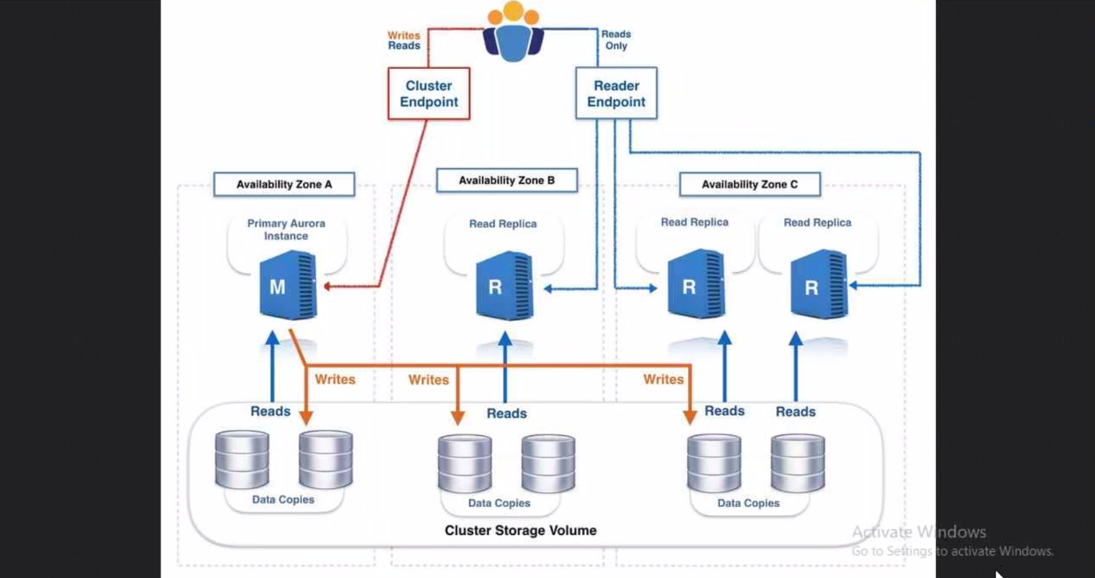

Here there are 3 replicas. the write done on primary DB then after write copied to replicas and we will create read end points from there will read the data from every replica.

You can maintain maximum 15 replicas. In MYSQL DB you need to increase or decrease the storage according to your requirement but here in AWS Aurora DB you don’t need to do increase the storage, the Aurora DB increase the storage for you.

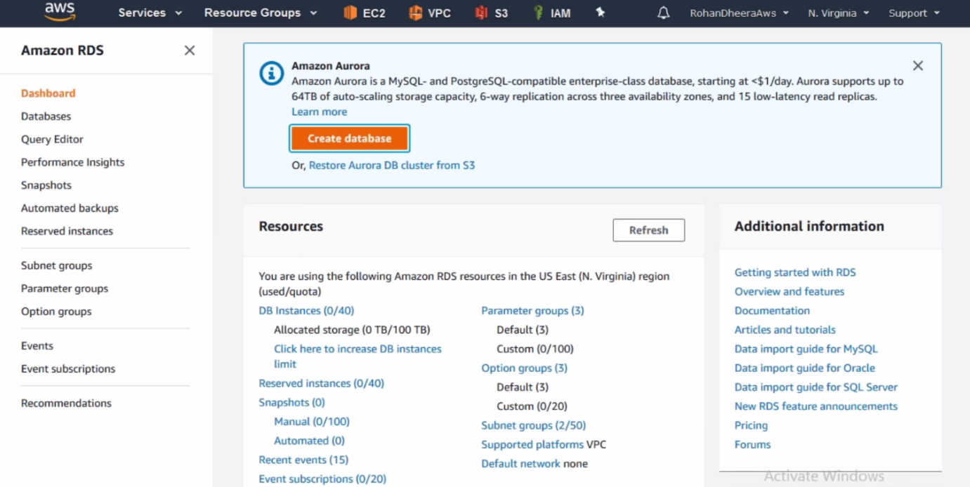

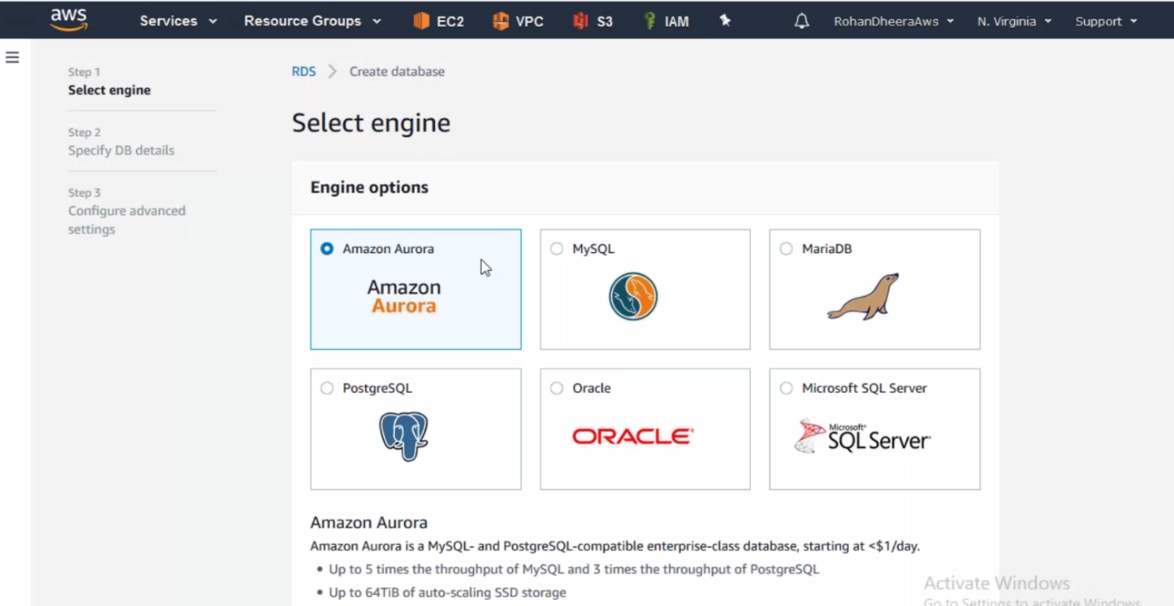

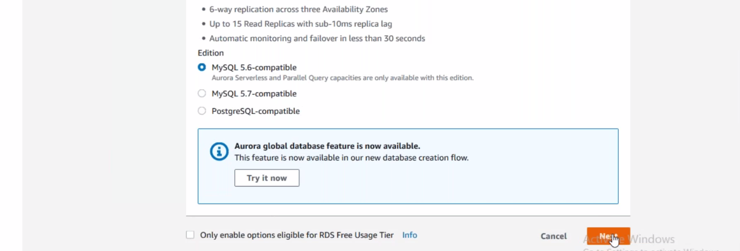

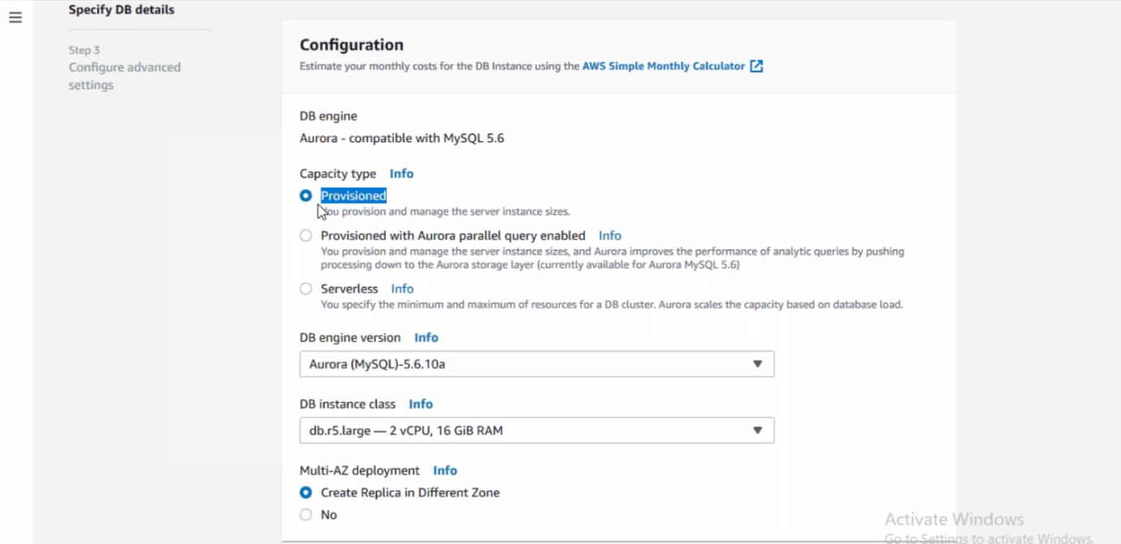

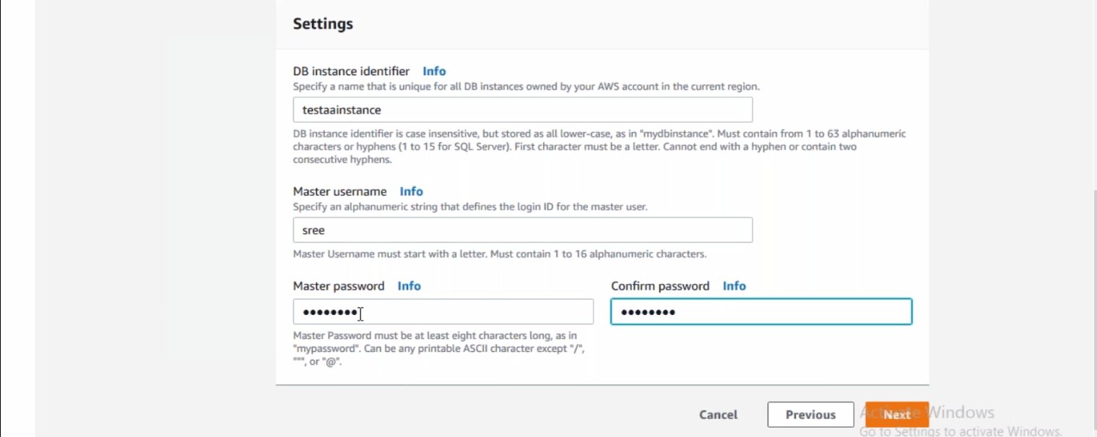

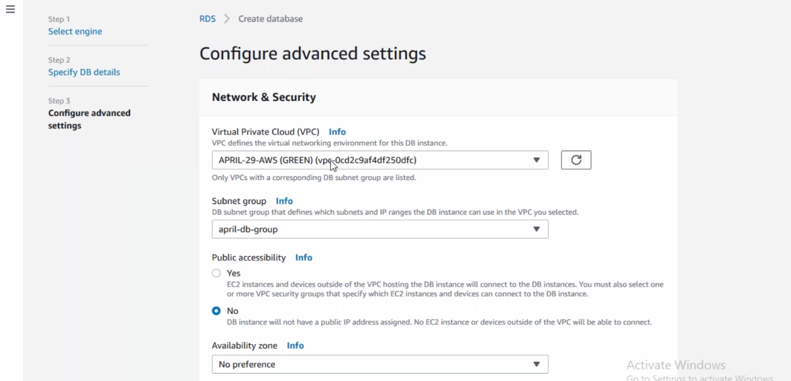

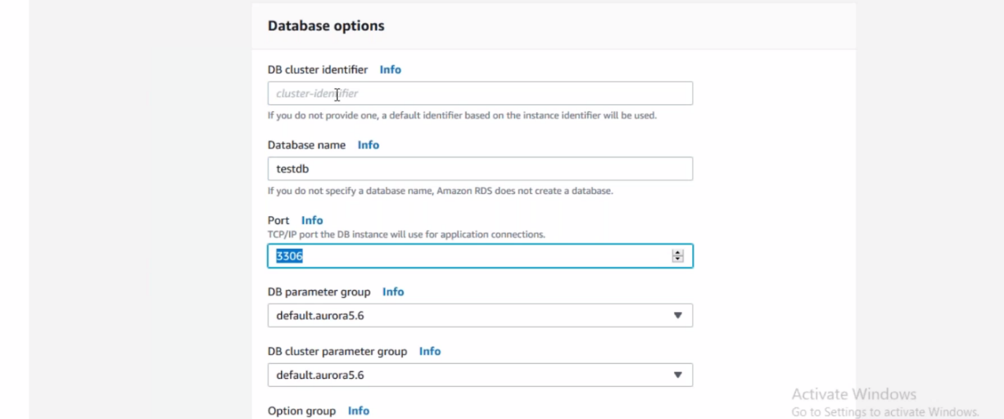

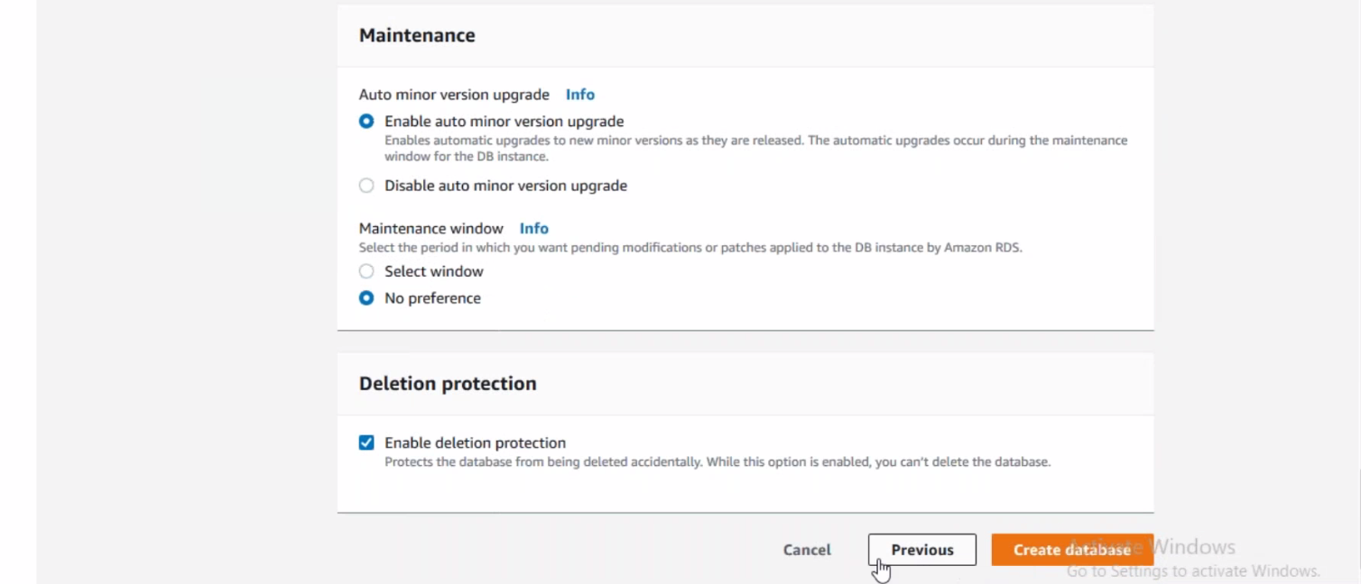

**AWS-Aurora DB Serverless**

Amazon Aurora DB also supports serverless means you don’t need to create instance. Server is managed by backend.







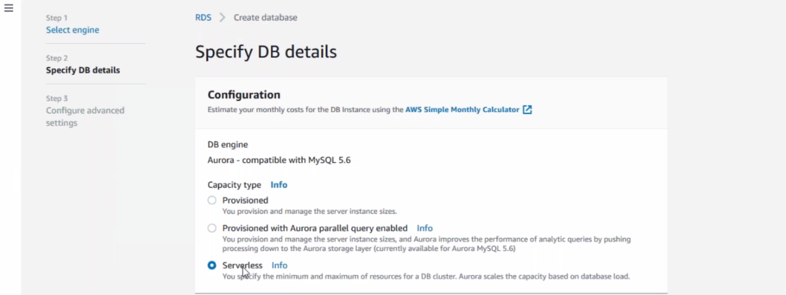

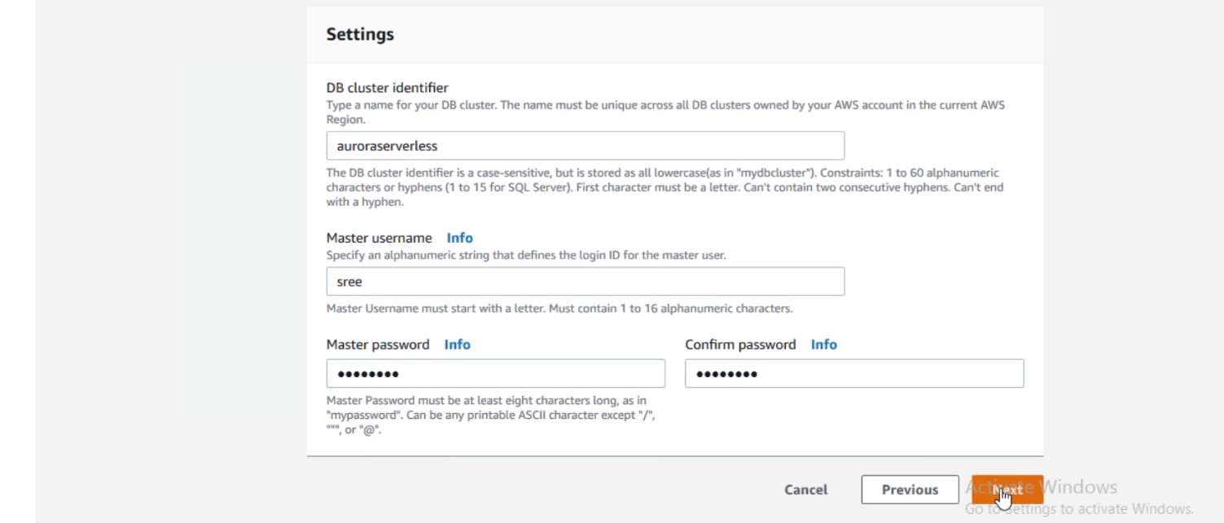

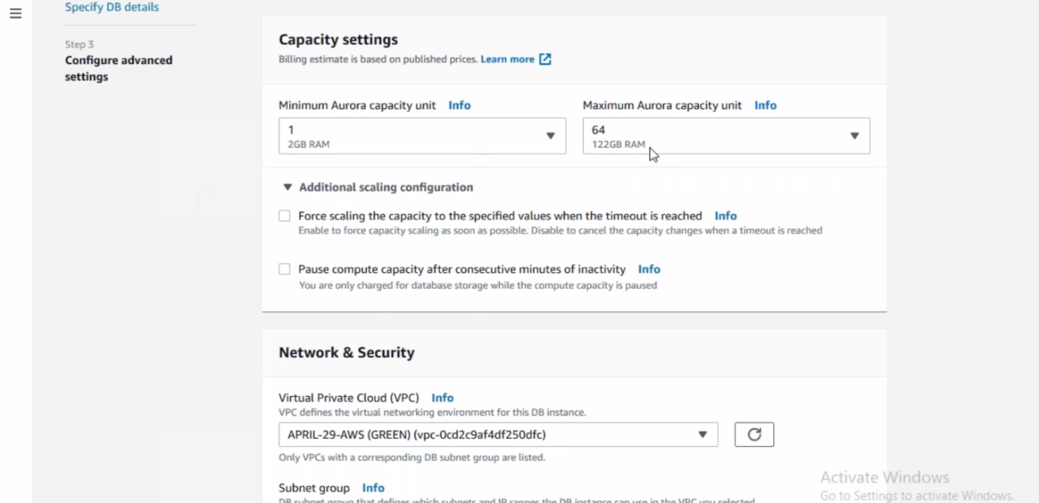

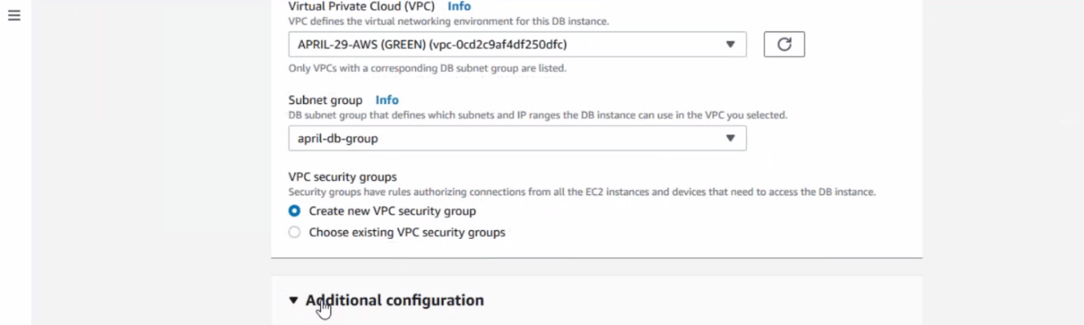

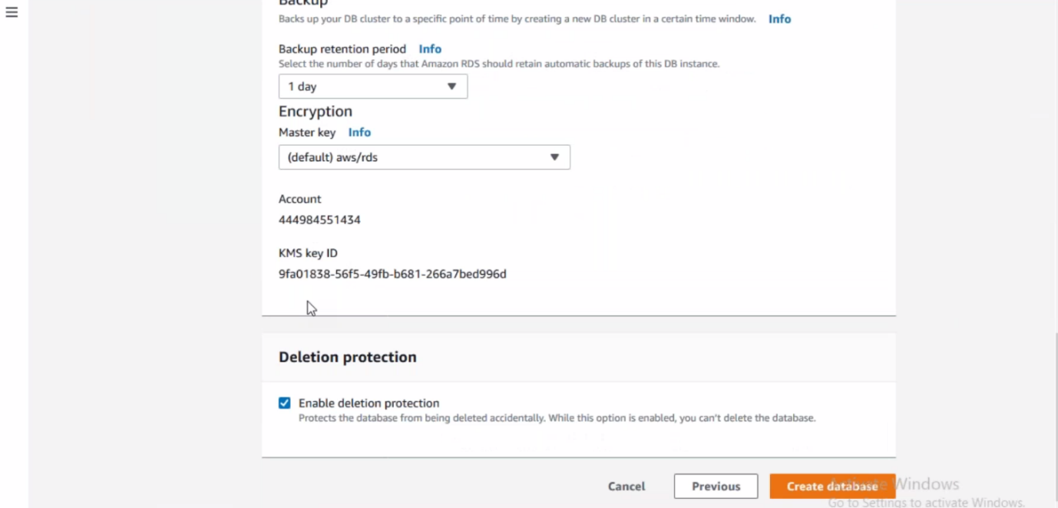

**DynamoDB**

The Amazon Dynamo DB is no SQL key, value pair DB

Here I will create Dynamo DB, Lambda, API Gateway then I try to write using API Gateway in Dynamo DB.

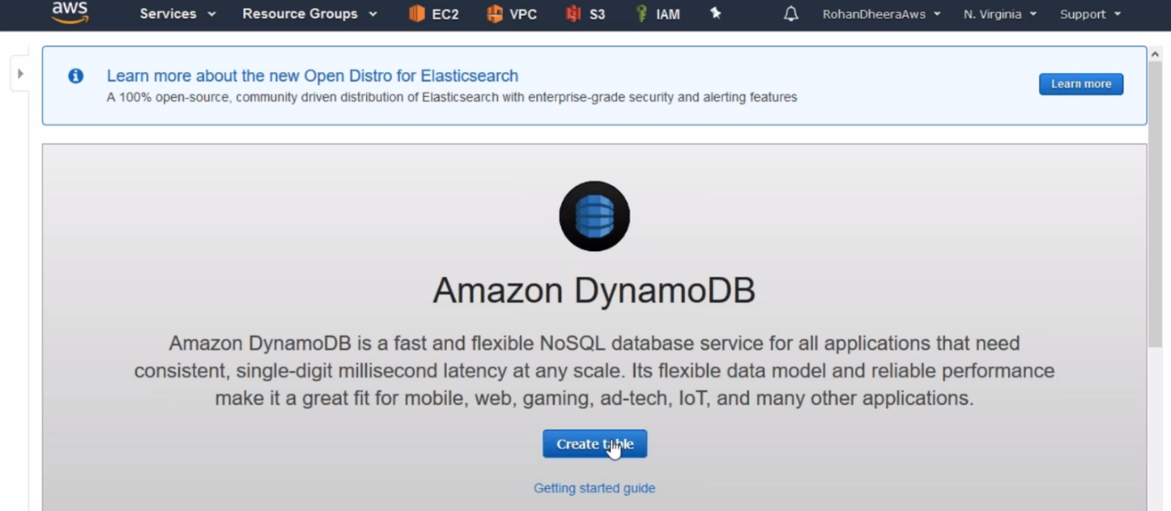

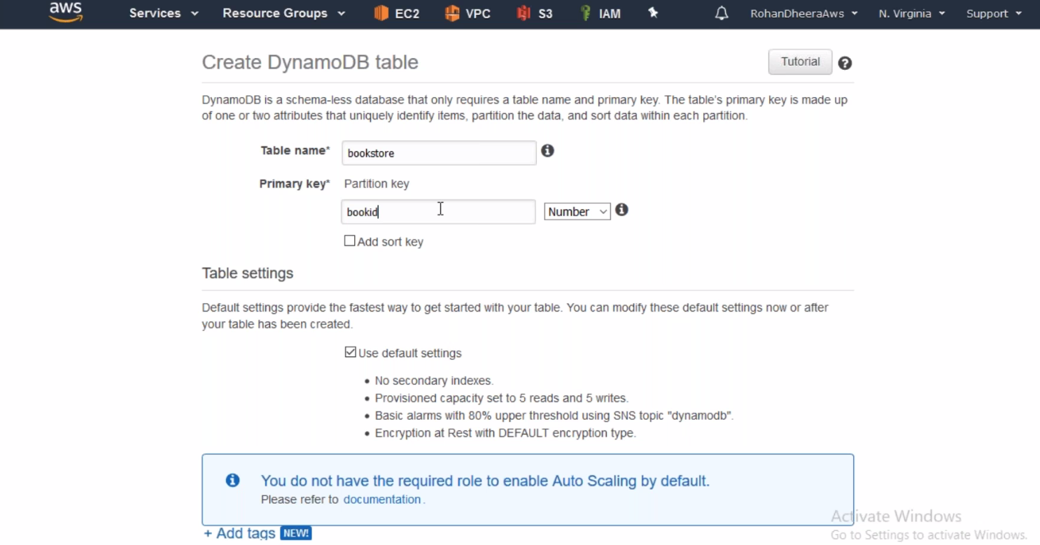

--- we will use this book id in lambda.

--- Click on create.

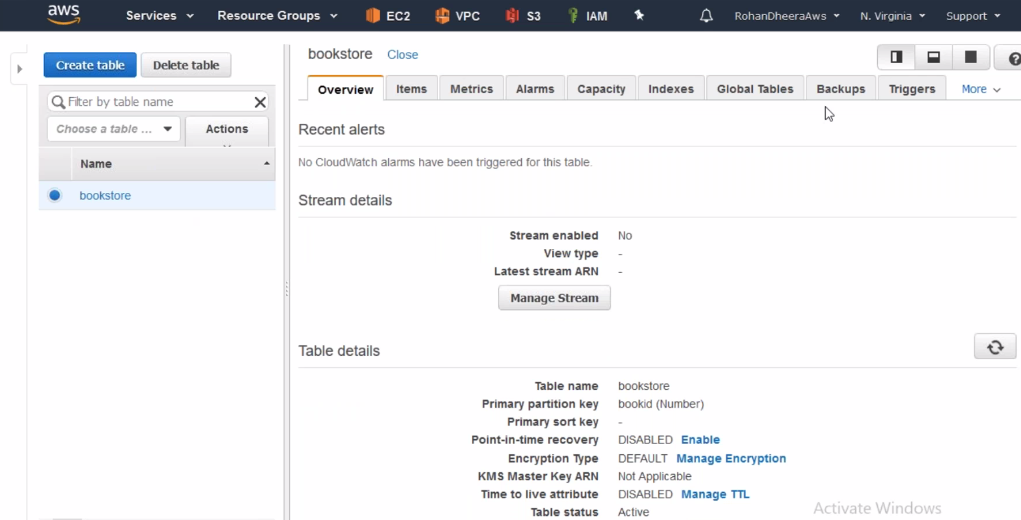

--- now the table is created.

--- now I am going to lambda and try to write in Dynamo DB.

**API Gateway**

it takes input and give out put, like the customers writes to API Gateway and that content will be forwarded to Dynamo DB, in the same way if customer askes for content it will take content from some gateway and give back to customers.

The API gateway have forward capability but not write capability. The API gateway cannot write directly to the Dynamo DB we have to maintain some meditator to write in Dynamo DB here that mediator is nothing but LANBDA

Here try to write data using lambda in dynamo db.

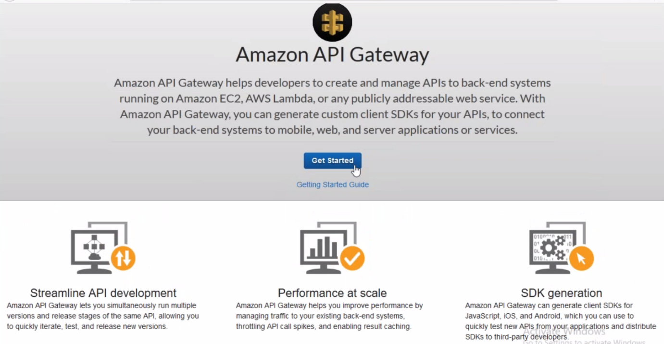

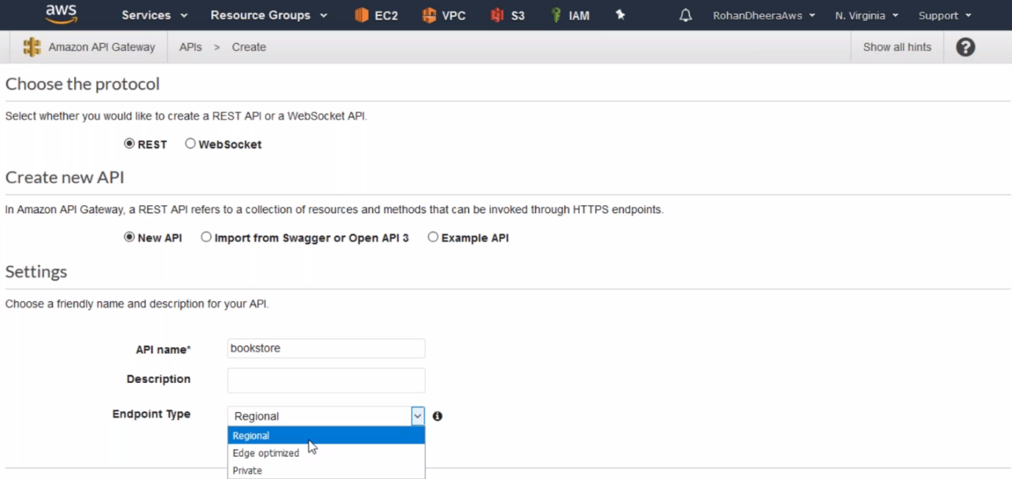

--- **Regional** – your application is for only one region then you use this Regional option.

--- **Edge optimized** – application in worldwide then use this.

--- Select the regional and click on create.

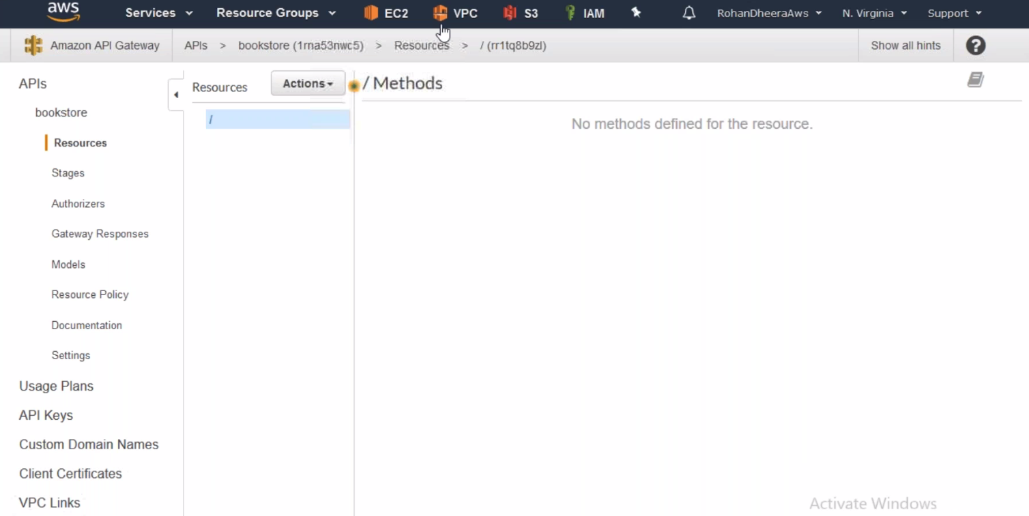

**Create resource**

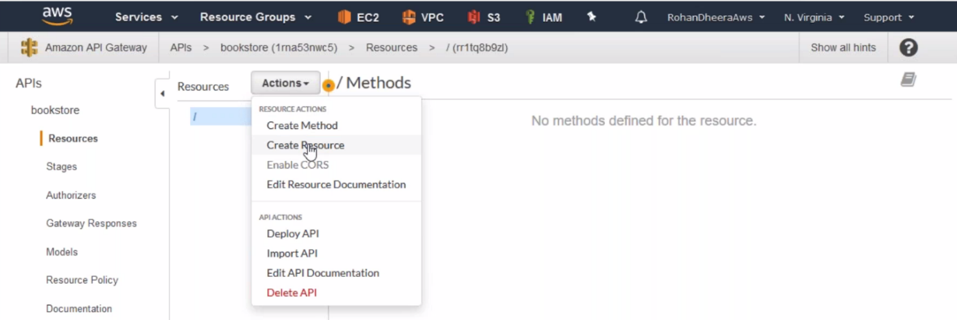

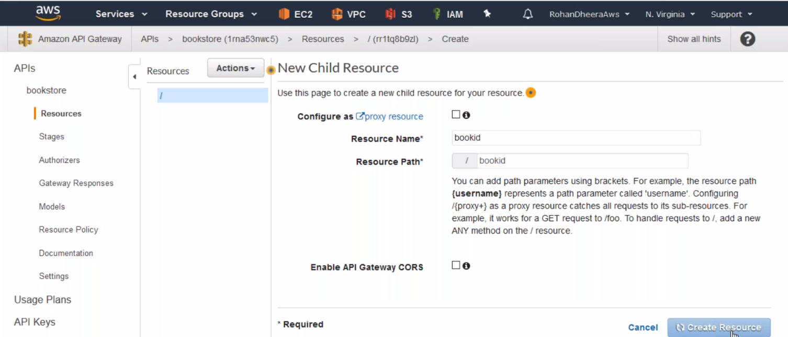

**Create Method**

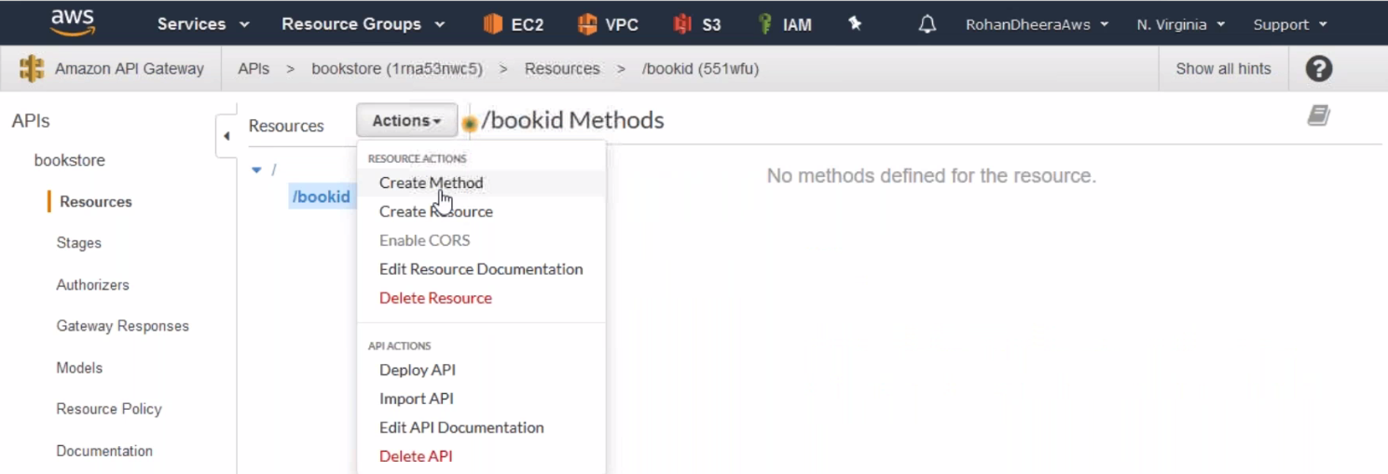

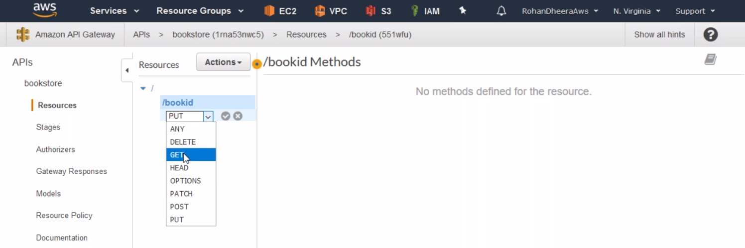

--- same process for put also

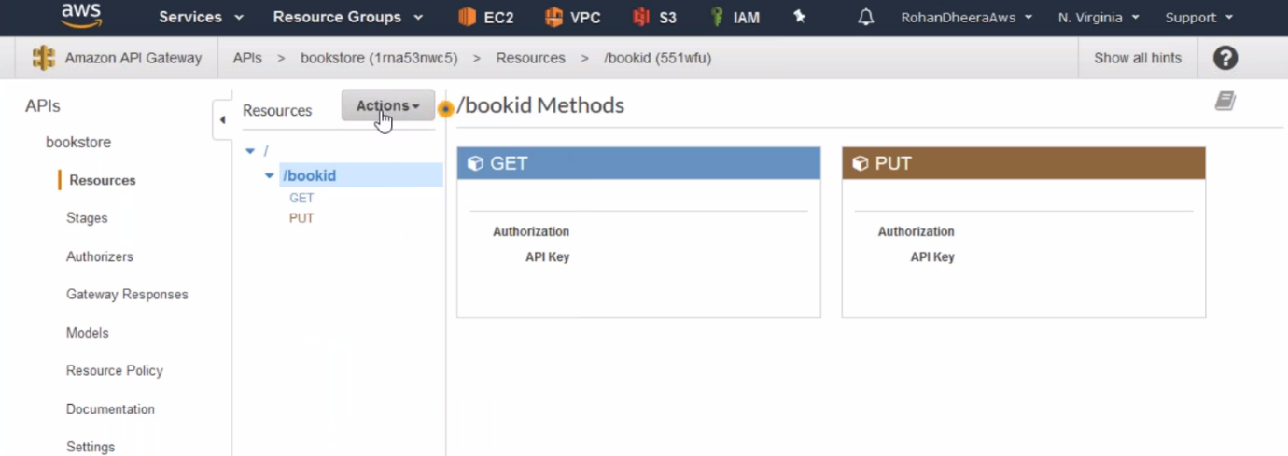

**Put**

Here put means write

--- Click on put

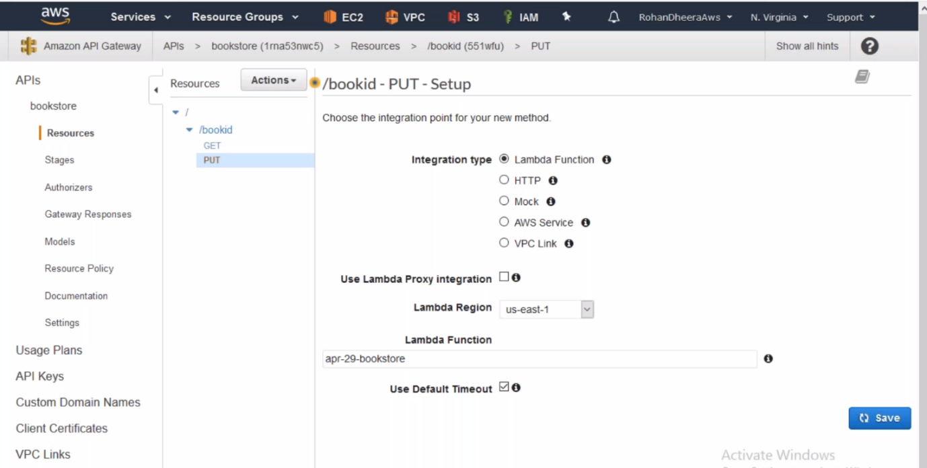

**Writing to dynamo DB using put**

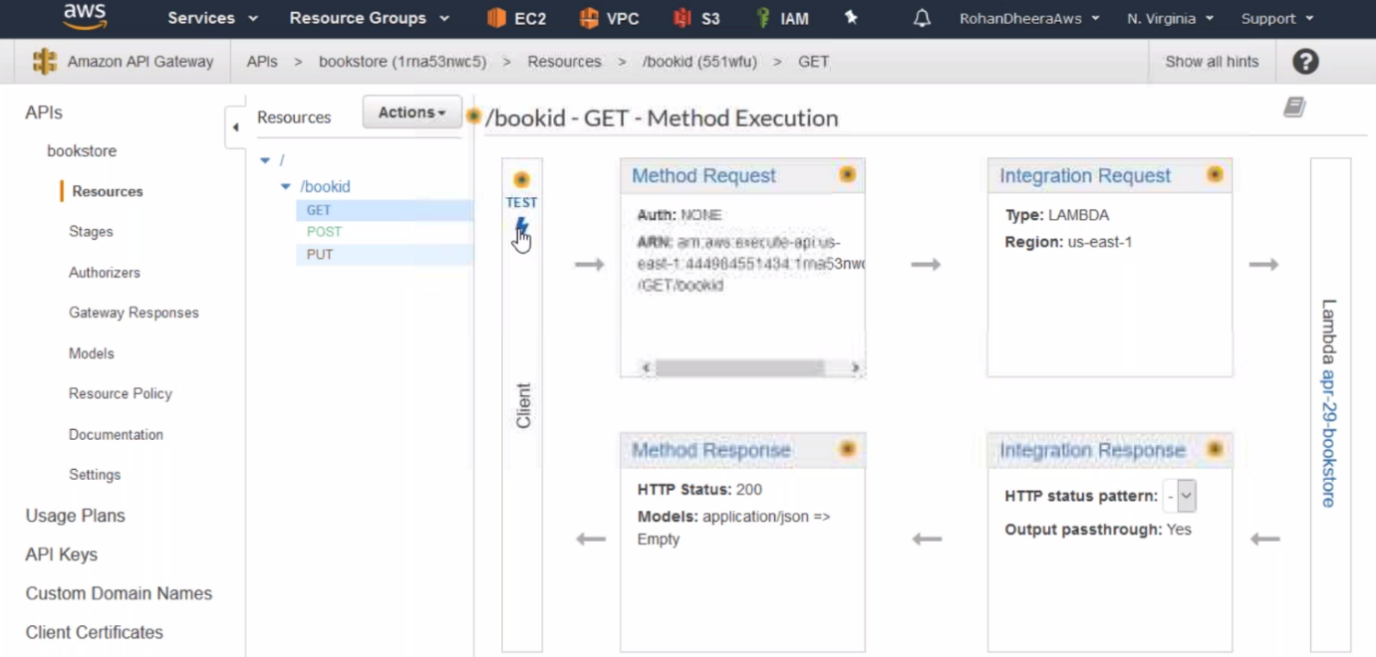

--- click on test

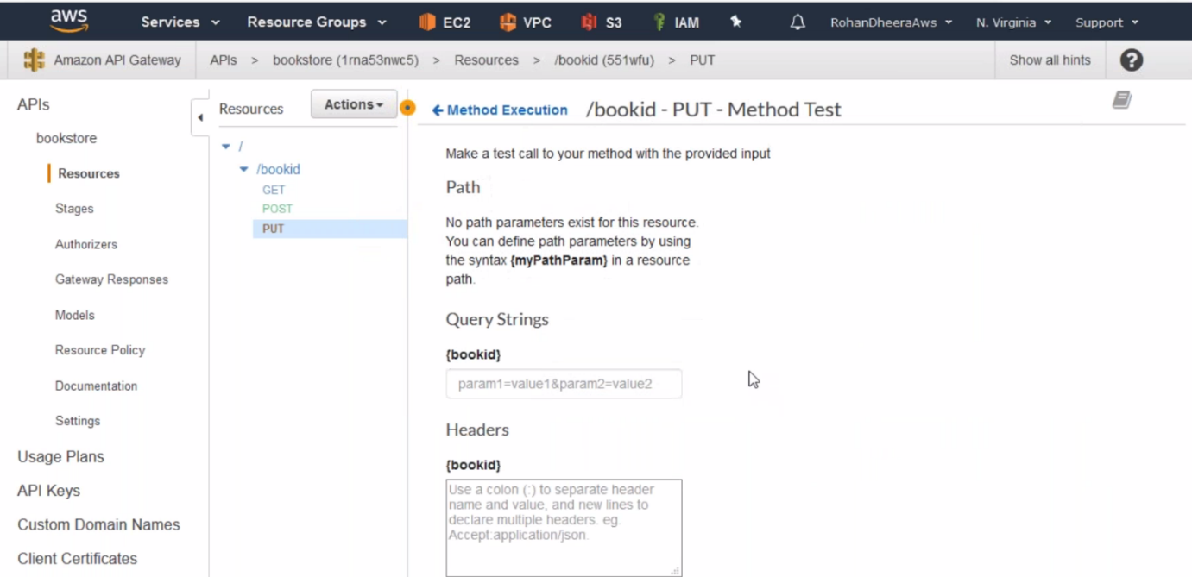

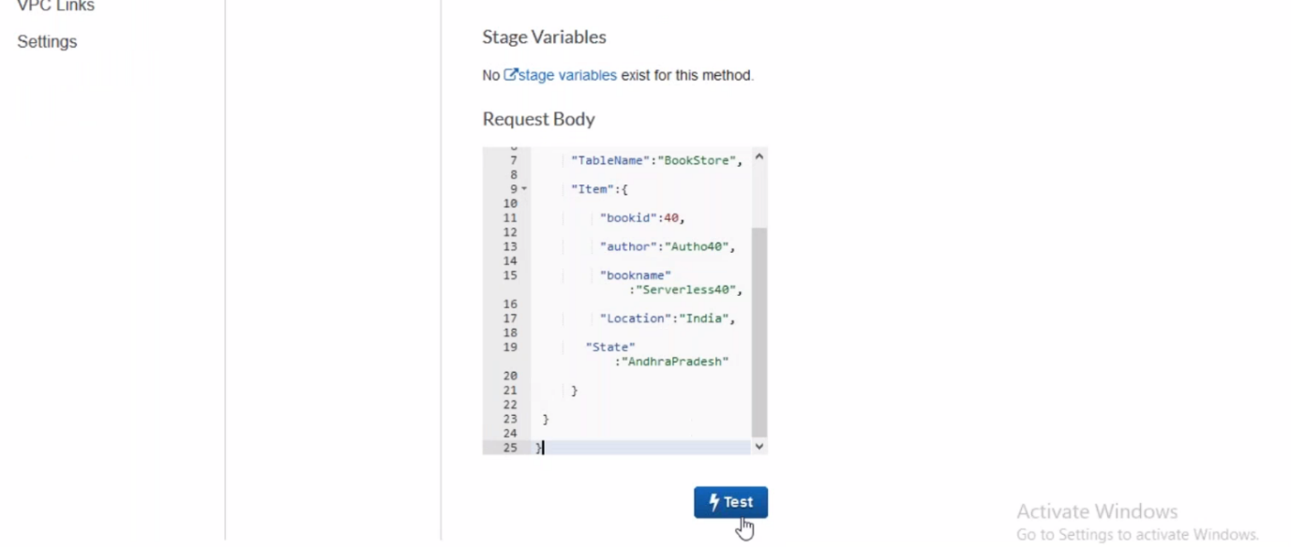

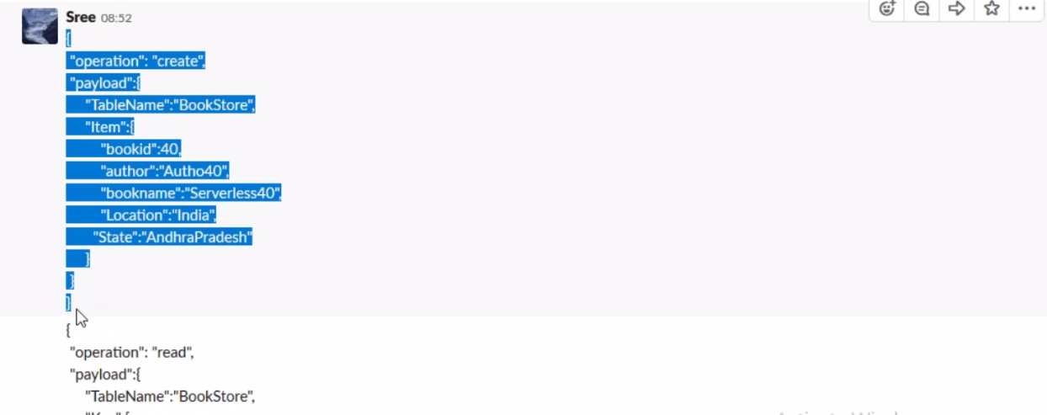

--- Use this code in above table.

--- click on test and see the changes in the dynamo DB.

**Get**

Here get means download

--- click on GET

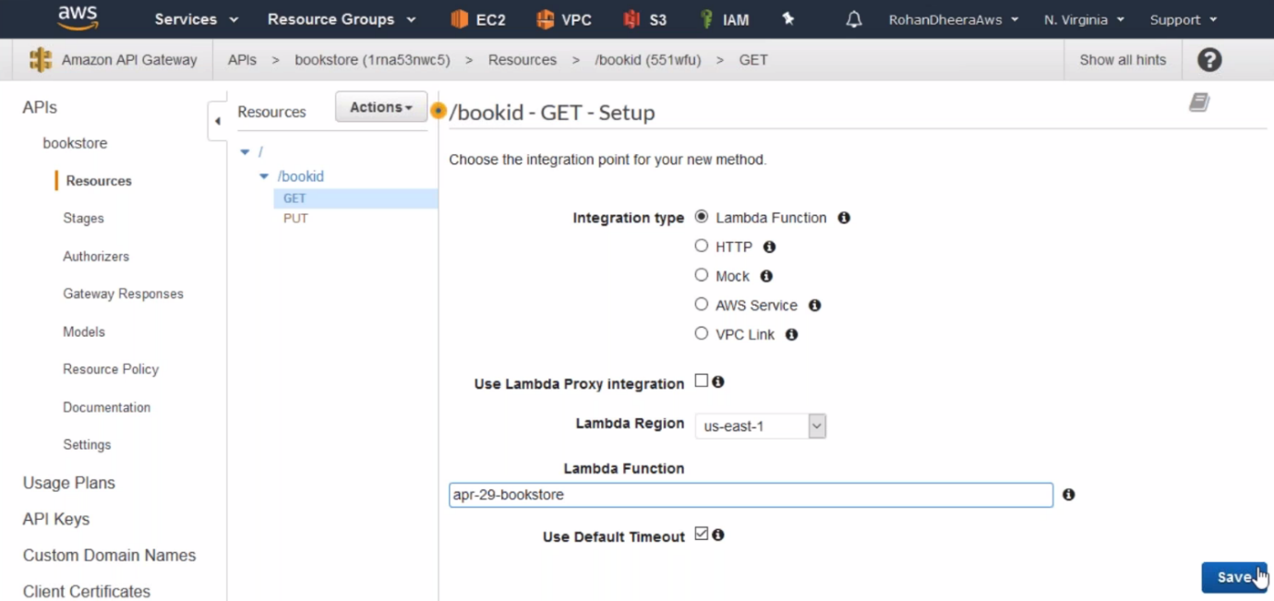

--- save it.

**Post**

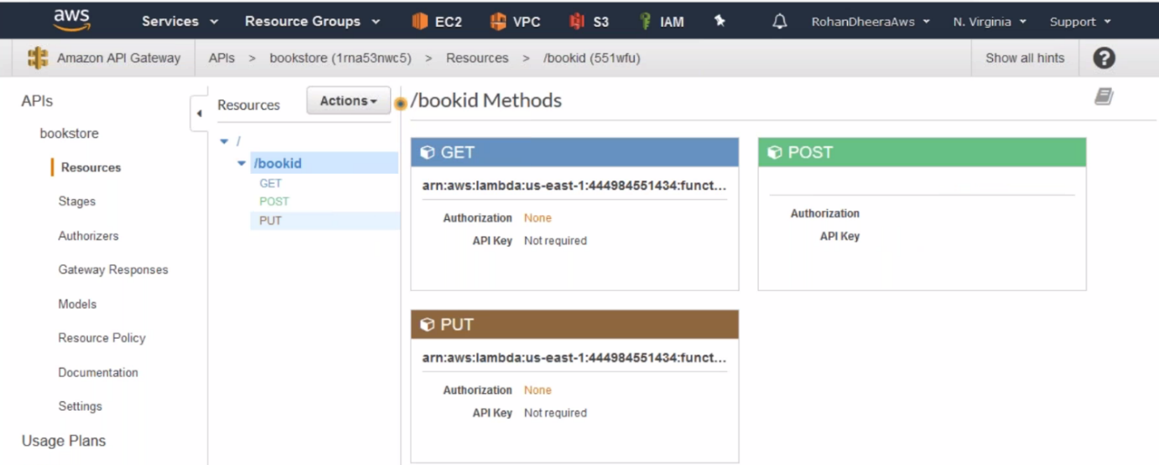

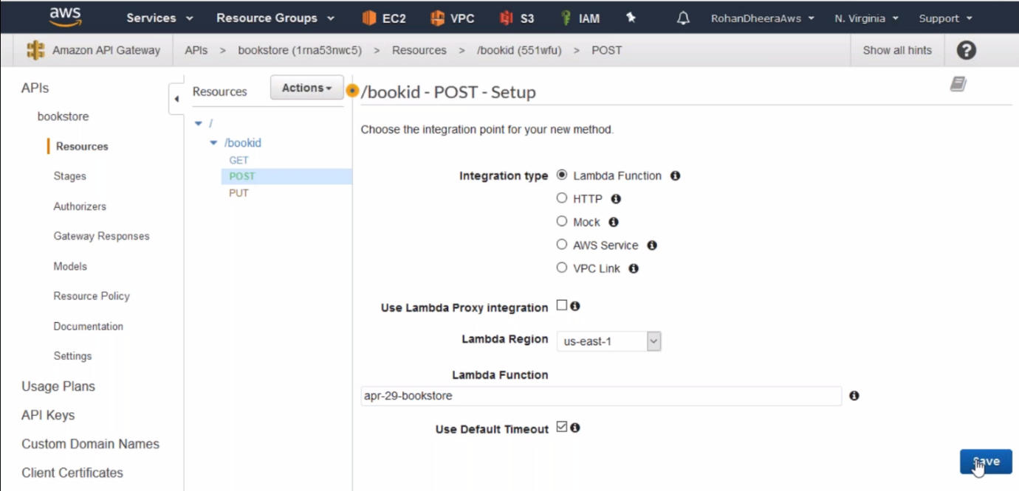

**Deploying API gateway**

You will get URL after deployment completed

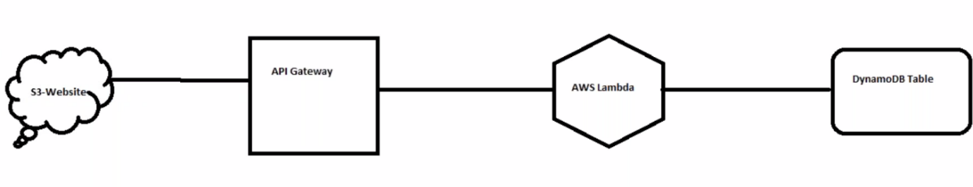

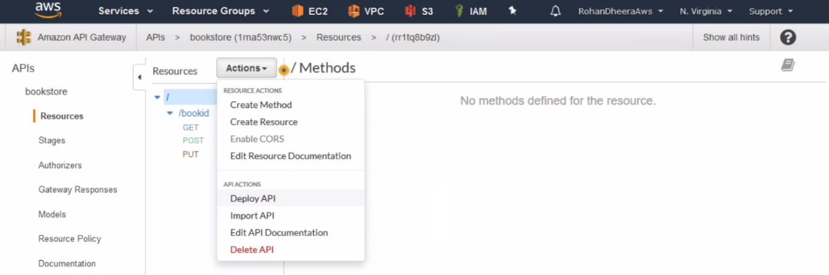

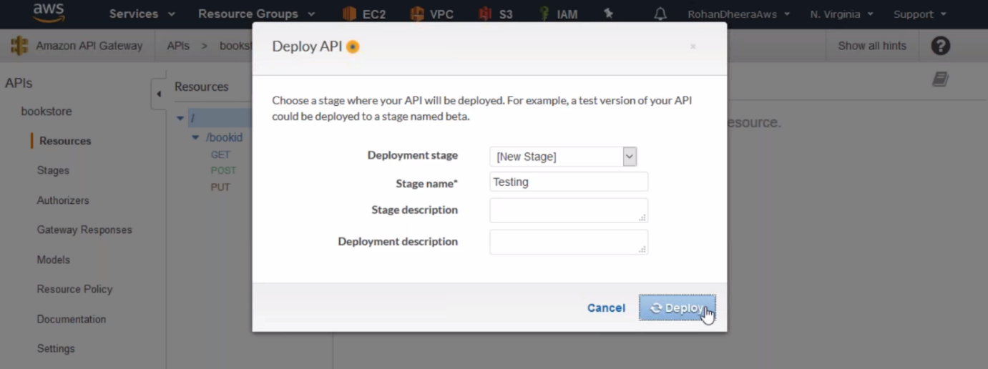

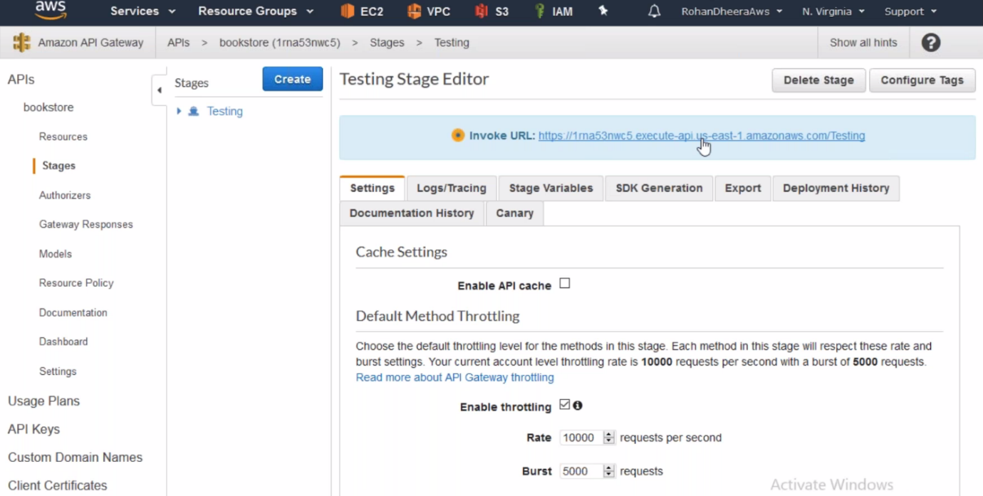

--- copy the URL

**REST CLIENT ONLINE**



When client accessed the website, the data will be transferred to API gateway and then form API Gateway to Lambda, AWS Lambda to Dynamo DB Table

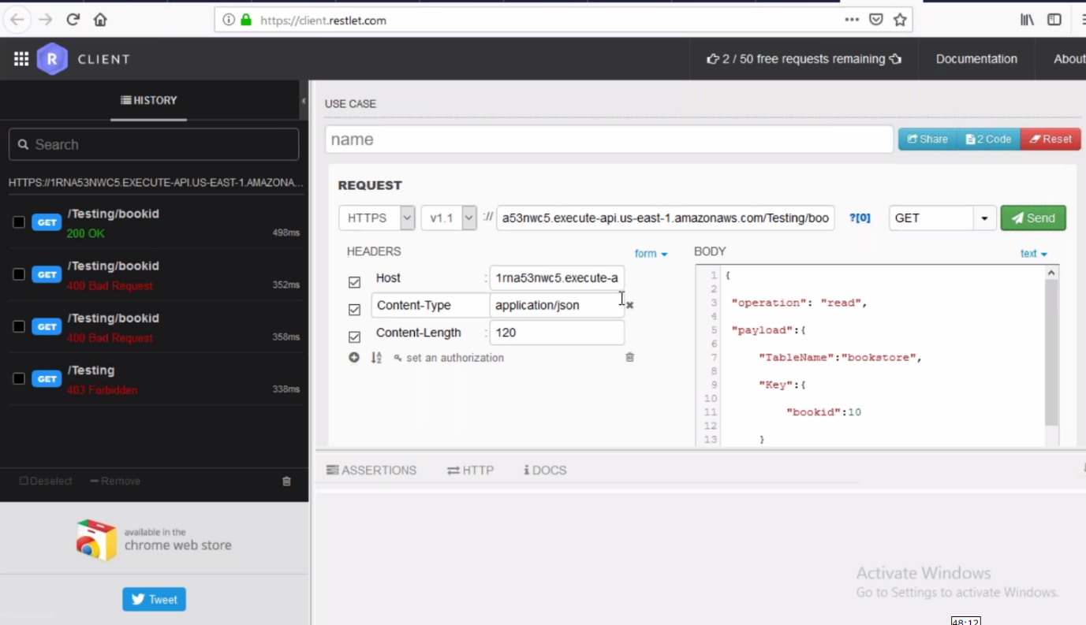

--- from API we have copied URL and click on send it will be sent to dynamo DB.

**AWS-Lambda**

Lambda is just script executer

The AWS-Lambda won’t do anything on its own, it will execute the scripts given by you. The script written in node js, Pyton, java, .net…etc.

The Lambda is integrated with API gateway and Dynamo DB

Here I am going to write date to dynamo DB by creating function.

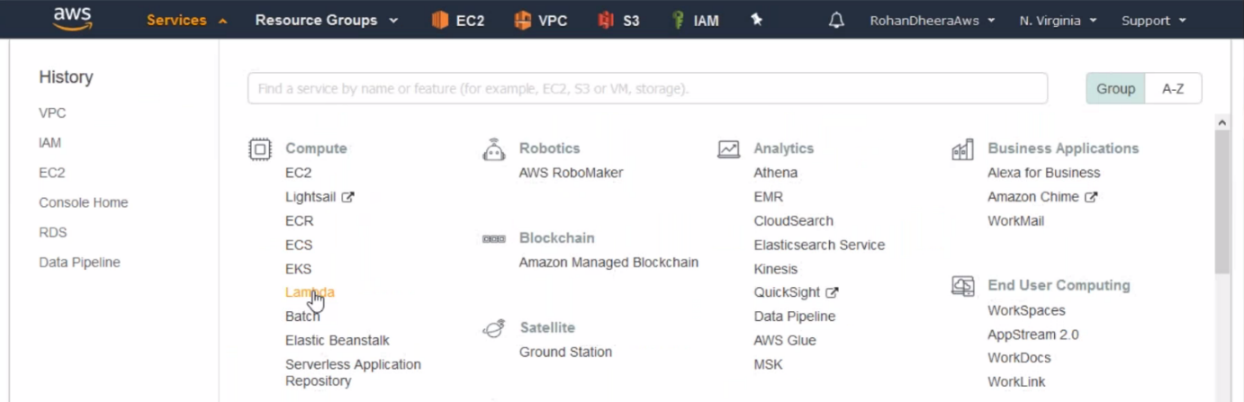

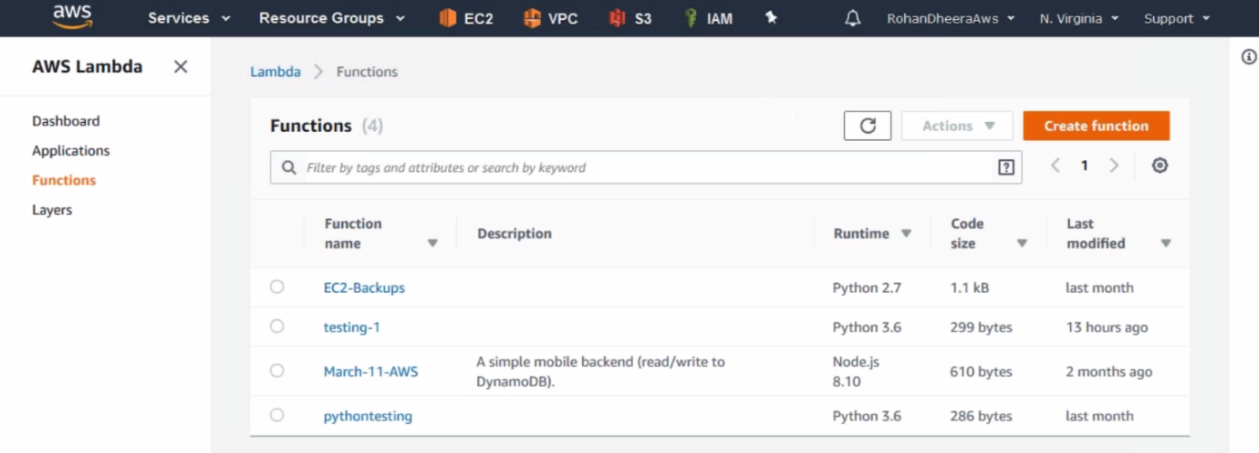

--- click on create function.

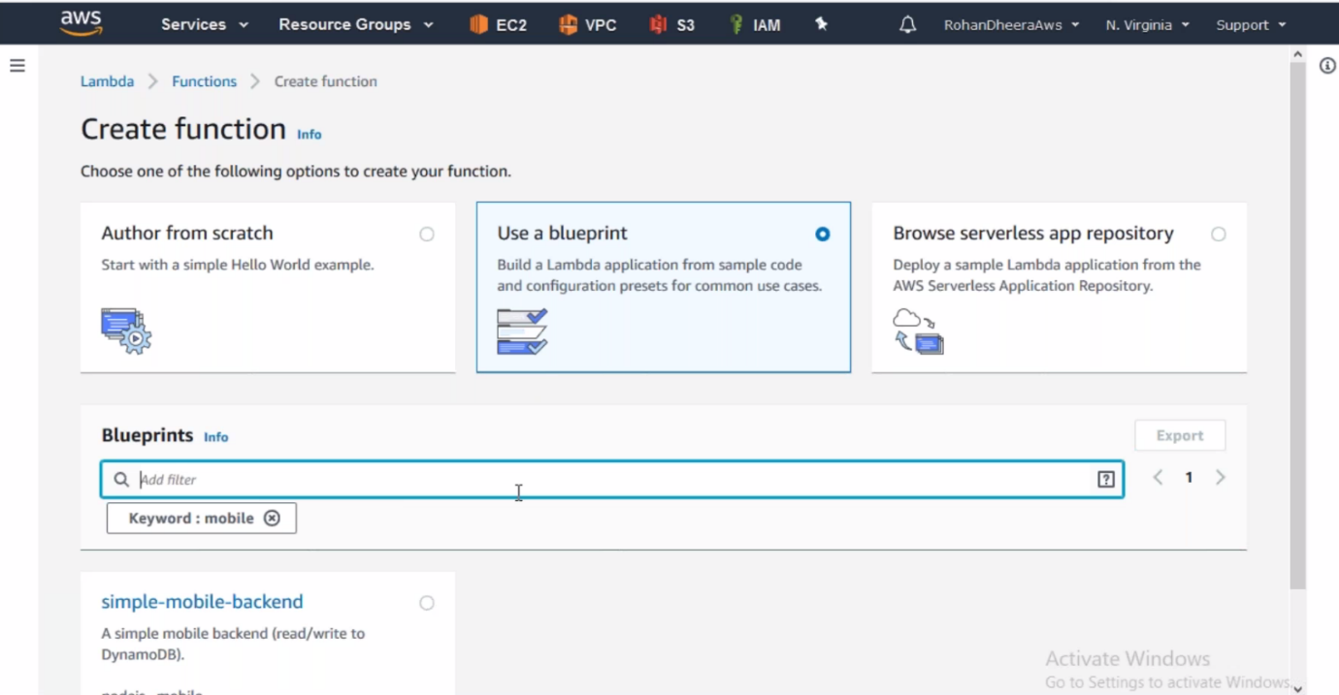

--- type mobile in search bar and SIMPLE-MOBILE-BACKEND will appear, Click on it.

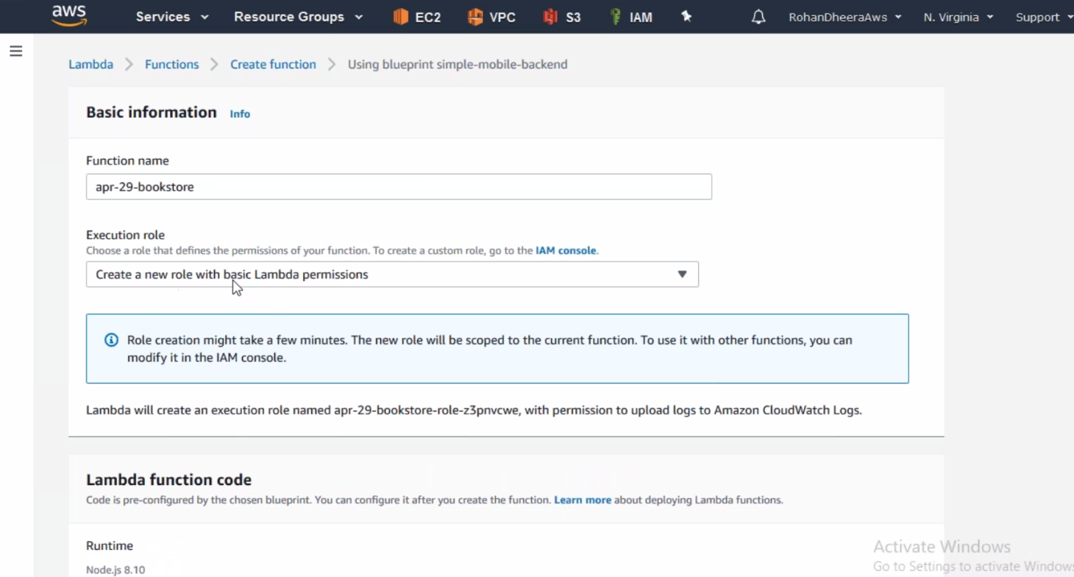

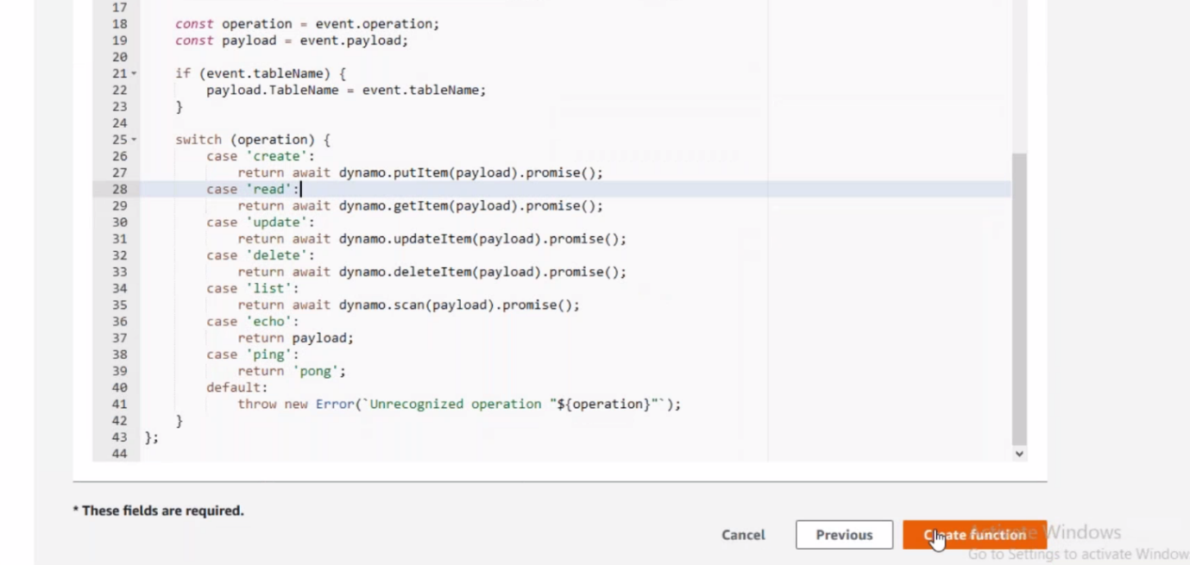

--- it will be created successfully.

**Giving permission on Dynamo DB in Role**

We need to give permission on Dynamo DB OR else it won’t work.

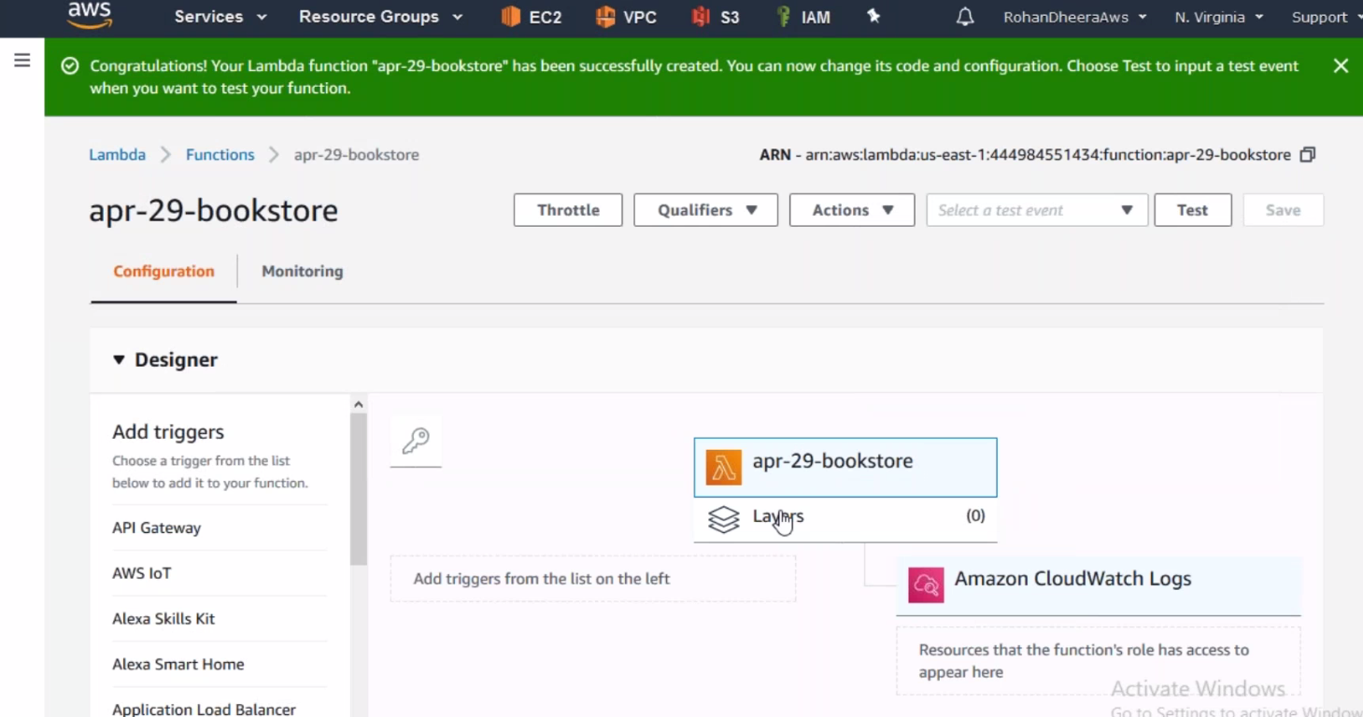

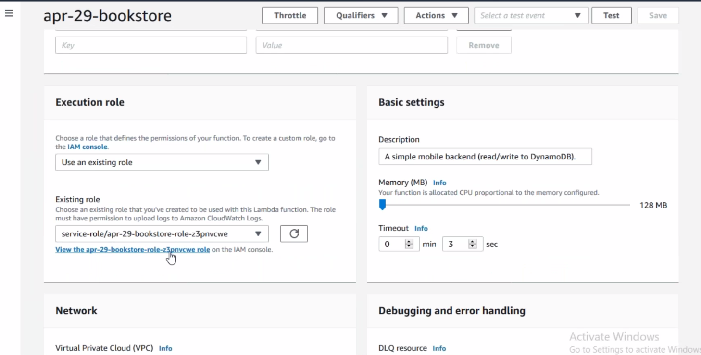

--- edit the role and give permission on dynamo DB

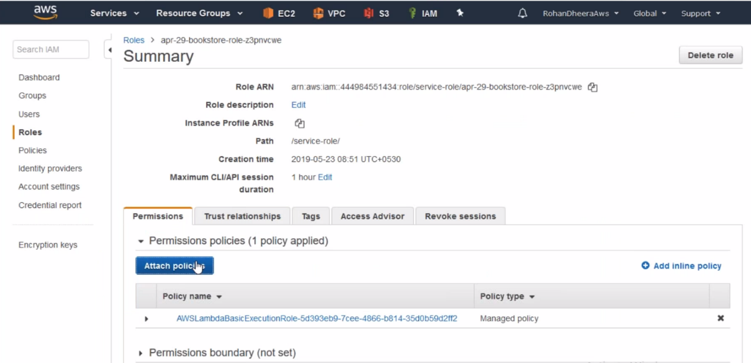

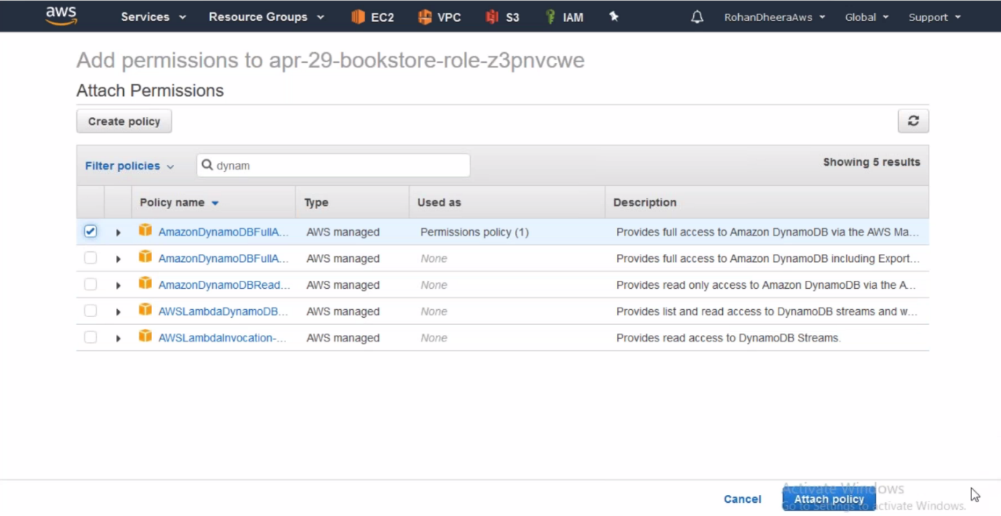

**Writing in Dynamo DB from Lambda**

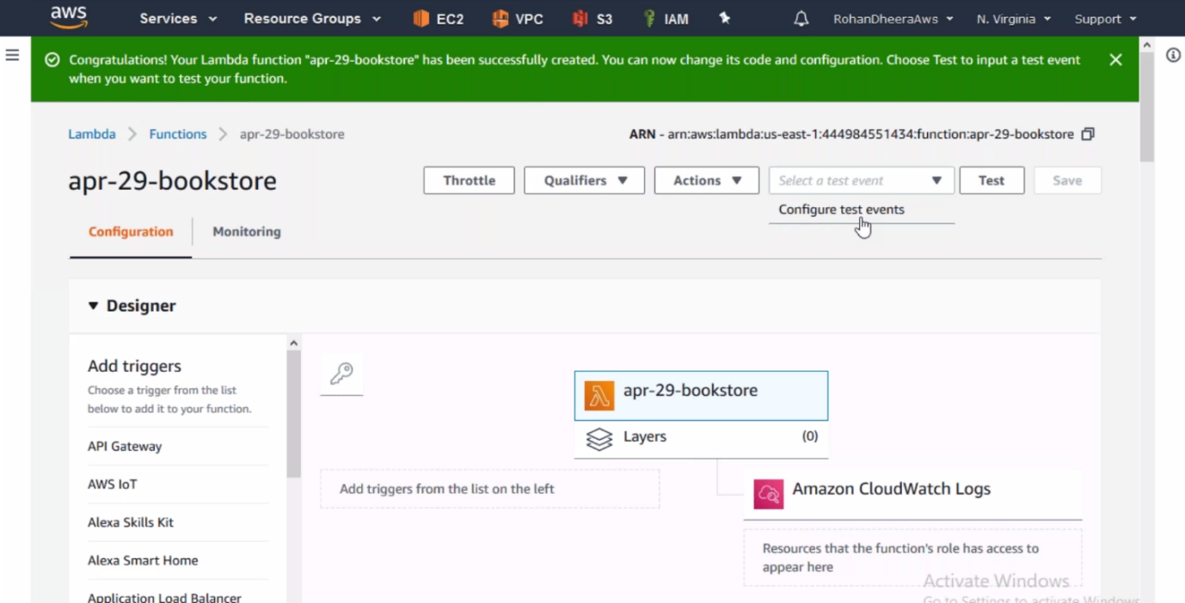

--- click on configure test event.

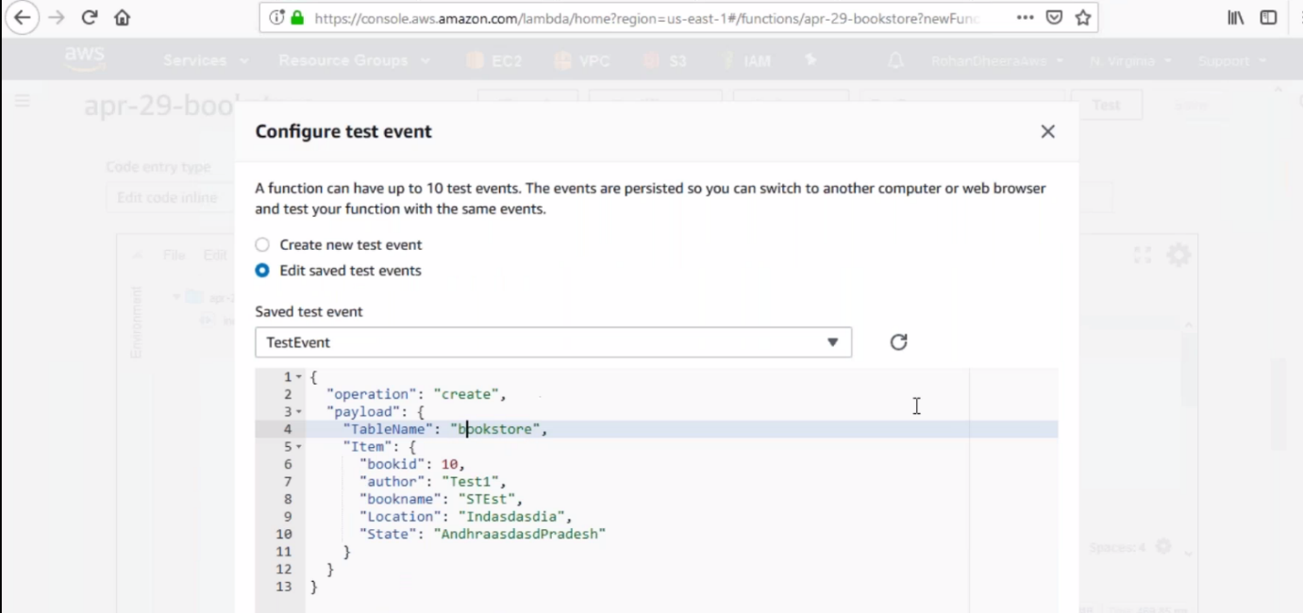

--- save it.

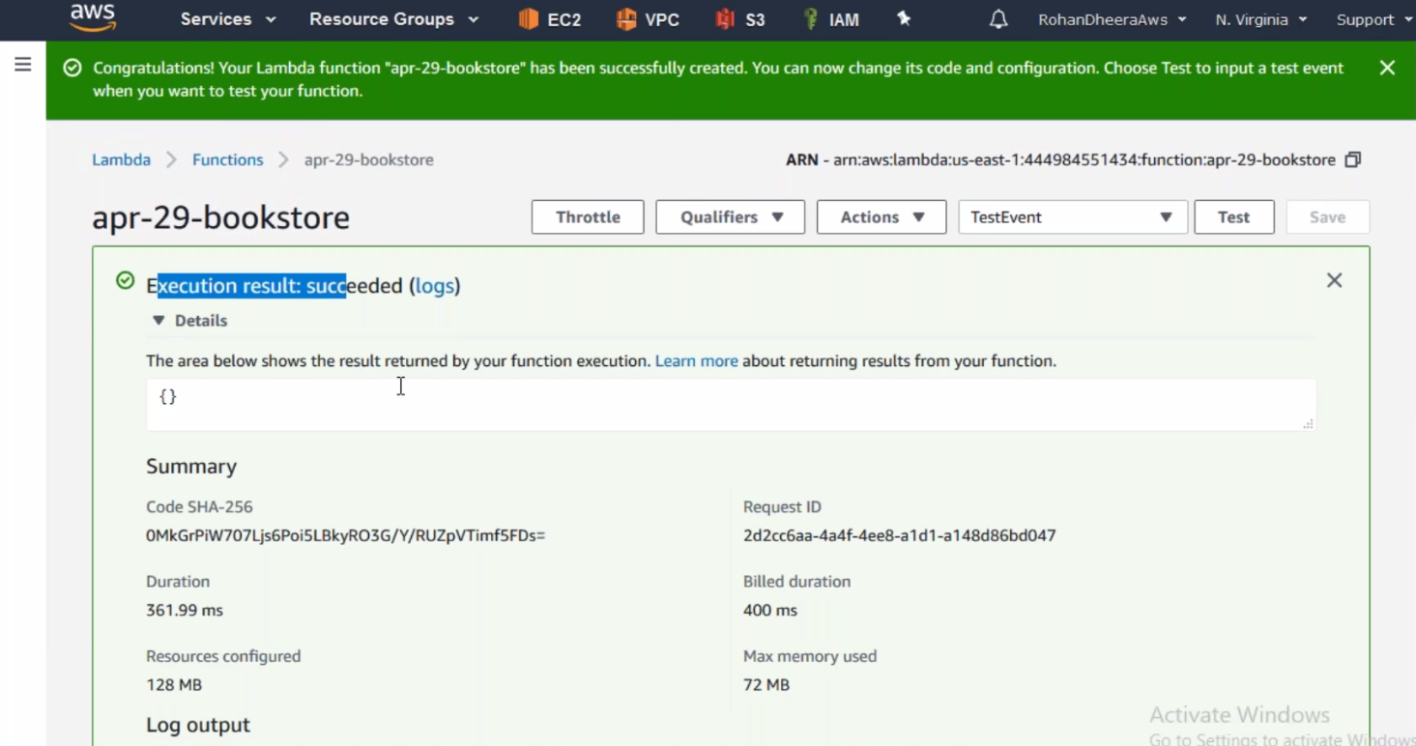

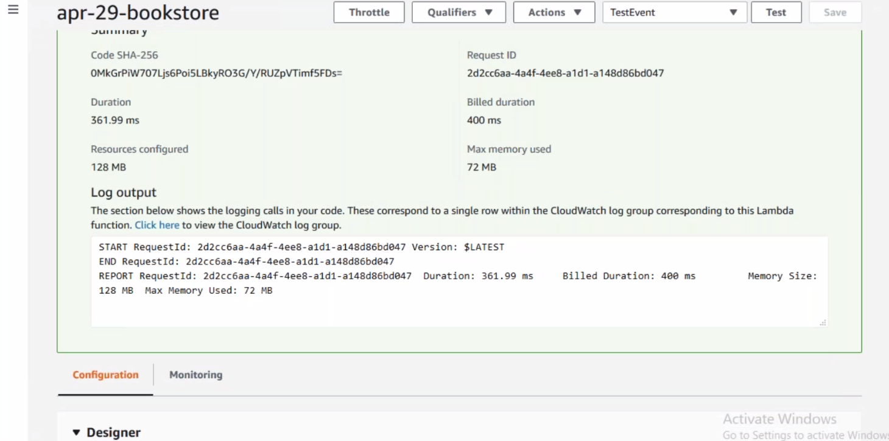

--- the write is successful in dynamo DB.

**For confirmation write is successful in dynamo DB in Lambda**

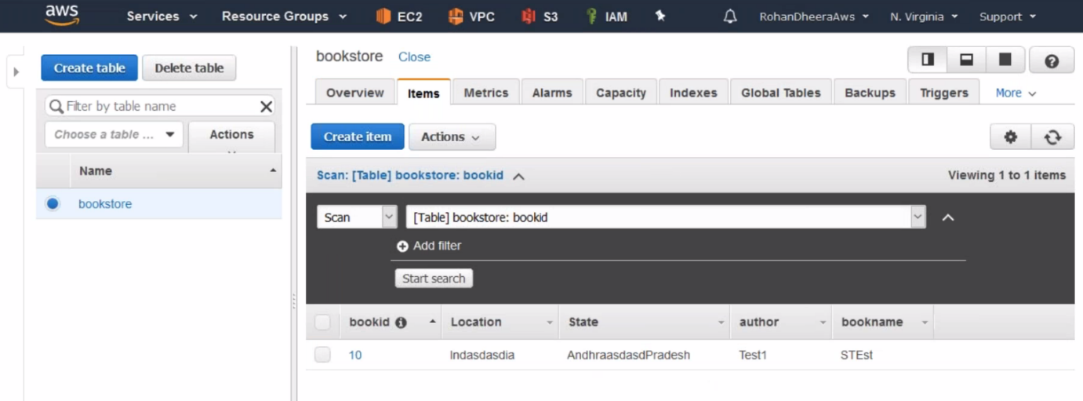

--- click on items to see write.